COMBURA 2022 Soesterberg, Netherlands, November 23-24, 2022

COMBURA 2022

A. Author* and B. Author**
e-mail of principal author
*Address of A. Author (Authors)

**Address of B. Author (Authors)

Abstract

This paper demonstrates the format for the extended abstracts for the COMBURA 2022 Symposium. Your paper must be submitted in this format. This paragraph demonstrates the format for the paper abstract that cannot exceed two pages, including references and images.

Font, Layout, and Margins
Papers must be written in English. Papers must be set in a Times New Roman type font. The maximum paper length is 2 pages. All figures and tables have to be included in the two-page limit.
The title of the paper and the author’s names and address(es) must be centered and at the top of the first page. The title should be in 16-point font, bold-faced, not italicized and in “Title Case” (upper case letters as used above). In the header above the title, the conference name, location, and date should be given in 10 points, italicized, not bold font, as shown above. This should appear on the title page only. The author’s name(s) should be in 12-point font and bold-faced. Next line should show the e-mail address of the author to whom correspondence should be directed, in 10-point font and not bold-faced. Address(es) should also be in 10-point font and not bold-faced. There should be one blank line between the title and the author’s name(s).
There should be two blank lines between the address(es) and the abstract. The heading “Abstract” should be 12-point boldface and centered. The text should be 12-point font and one column, the full width of the margins. The extended abstract should state the most important specific objectives, the major results, and the most significant conclusions of the paper. The authors can divide the text in sub-paragraph, but should not use sub-sections.

The size of the page has to be 21 cm x 29.7 cm (A4) in portrait format. The text must be set in one column with a 12-point font. Font sizes less than 12 points will not be accepted. The column should be 160 mm wide, with 2.5 cm right and left margins. Upper and lower margins have to be 2.0 cm and 3.0 cm, respectively. Text, figures, and tables should be centered on the page, left-to-right and top-to-bottom.

Headings of sections within the paper should be bold-faced and aligned to the left of the column. The text should begin on the next line after a heading. There should be one blank line between the end of one section and the heading of the next section. Paragraphs should begin with 6.6 mm (approximately 3 letters in 12-point type) indentation and should be fully justified, except the first paragraph after all headings that should be aligned the left of the column and fully justified. Hyphenation should be used to make word spacing as uniform as possible. Page numbers should not be included.

Submission
Page numbers should not be included. Papers have to be submitted in PDF format via the website at www.combura.nl before October 15th, 2022, at 23.59 hour Amsterdam time zone.

Figures and Tables
Figures and tables should be numbered separately, and the order in which they appear should correspond to the order in which they are referenced. The word “Figure” and its number and the word “Table” and its number should appear in bold faced Times type font of 12-point size, followed by a period, followed by a caption in normal 12-point font, as illustrated in by the figure and table in this document. Captions should be centered. The word “Figure” may be abbreviated in the text but not in the figure caption. The word “Table” should not be abbreviated. See Figs. 1 and 2 and Table 1 in this document for examples. Figures and tables should appear in portrait format whenever possible.
Figures and tables may appear in the text as they occur. The labels, symbols and other information on the illustrations should have minimum size corresponding to a 12-point Times New Roman font when printed.

Table 1. Example of a table.

Column 1 | Column 2 | Column 3
1 | 2 | 3
4 | 5 | 6
7 | 8 | 9

Units
Please use SI units.

Equations
Equations should be centered, with the equation number in parentheses in sequential order included right-justified, as in the below equation,

F = ma. (1)

Equations should be separated from text by one line, and may be referred to by equation number. All symbols should be printed in italics or otherwise according to conventional practice, both in the equations and in the text. An example of how italics and equation numbers should be used is given here in referring to the force F in above.

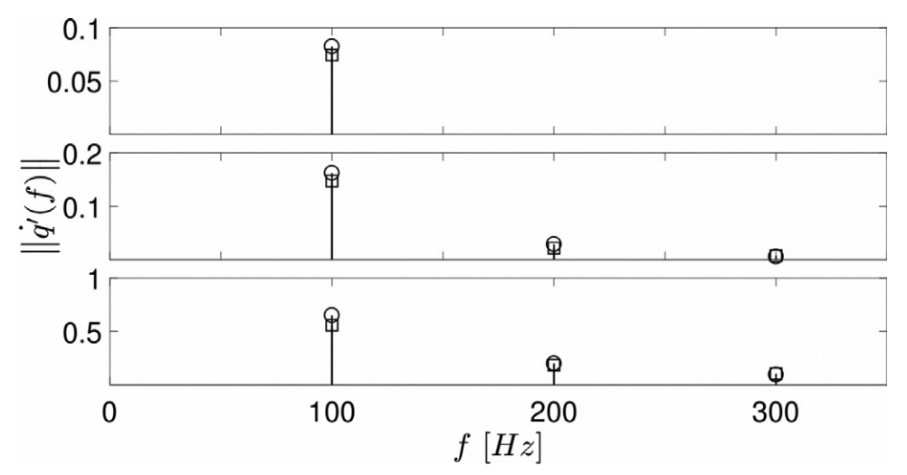
Figure 1. Example of a figure.

Nomenclature
No nomenclature is allowed. You should introduce any symbolism or acronyms as soon as they are used.

References
References should be indicated in the text by full sized numbers enclosed within square brackets, as illustrated in the examples below.

[1] Rolando, A., Allouis, C., Beretta, F., D’Alessio, A., D’Anna, A., Minutolo, A., “Measurement of particulate volume fraction in a co-flow diffusion flame using transient thermocouple technique”, Comb. Sci. and Tech. 176: 945-958 (2004)
[2] Lefebvre, A.W., Gas Turbine Combustion, McGraw-Hill, 1983, p. 130.
[3] Pitcher, G., Wigley, G., “Two component velocity and size measurements for a non-combusting fuel spray in a Diesel swirl combustion chamber”, Proc 10th International Conference on Liquid Atomisation and Spray Systems, Rouen, France, paper VII-11, pp 766-773.
[4] Alluis, C., Beretta, F., D’Alessio, A., Borghese, A., “Ultraviolet absorption and fluorescence measurements in turbulent spray flames”, Proc. Comb. Inst. 28:311-317 (2000).

